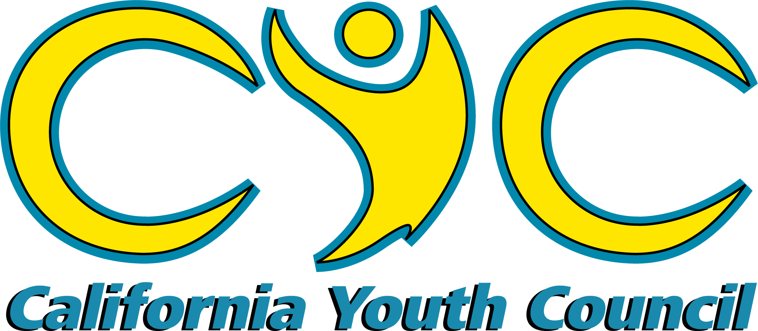

A statewide coalition of FNL youth, ages 14-24
2020-2021 California Youth Council
Application Packet
Submit completed application packet by April 30th, 2020

Please read this page in its entirety before continuing.
Application Check List:

- Part 1: Application
- Part 2: Nomination Form
- Part 3: Cover Letter & Résumé
- Part 4: Letter of Understanding
- Part 5: Parent Consent
- Part 6: Guidelines & Expectations
Mark Your Calendars:
- Completed application packets must be received by the CFNLP no later than April 30th, 2020 (late applications will not be considered).
- CYC conference calls will occur monthly for the majority of the year, and biweekly in the months leading up to the 2020-2021 Youth Summit. CYC members and adult allies will determine the recurring call date together.
- As a group, the CYC will schedule the first in-person meeting for some time in July, 2020.
Other Items to Note:
- Commitment & full participation is a requirement and expectation for all members throughout the entire CYC year. Members should not miss more than three CYC conference calls throughout the year.
- Applicants are expected to have had a high level of experience with the Friday Night Live Standards of Practice to be considered.
Submitting Your Application Packet:
- Completed application packets should be submitted to the CFNLP no later than
- Receipt of delivery is the responsibility of the applicant.
- Applications may be submitted via email, fax, or postal mail:
  - Email to: azulie.wilson@tcoe.org
  - Fax to: (559) 737-4231
HAVE A QUESTION? CONTACT:
Kellie Faulkner
Program Analyst,
California Friday Night Live Partnership
(559) 733-6496 x1274
kellieg@tcoe.org

  - Send mail to: California Friday Night Live Partnership
Attention: Kellie Faulkner
6200 South Mooney Blvd.
P.O. Box 5091
Visalia, CA 93278-5091

Part 1: Application
Please PRINT legibly.

APPLICANT
Full Name: _________________________________________________________________________________
Preferred Name (Nickname): __________________________ Date of Birth (MM/DD/YYYY): _________________ Gender: ________________ Ethnicity: _________________ E-mail Address: ___________________________ Home Phone: ______________________ Cell Phone: _______________________ Texting: Yes No
Mailing Address: _______________________________ City: ____________________ Zip Code: ___________
Representing County: ________________________________ Grade as of Fall 2020: _____________________

APPLICANT’S PARENTS/GAURDIANS
Full Name(s): _______________________________________________________________________________
Home Phone: _________________________ Cell Phone(s): _________________________________________
Primary Language(s) Spoken at Home: __________________________________________________________

SCHOOL
Name: _____________________________________________ Phone: _____________________________
Address: _________________________________ City: ______________________ Zip Code: ____________

FRIDAY NIGHT LIVE
Are you an active member of Friday Night Live in your community? No Yes
If yes, in what capacity (check all that apply)? FNL School Chapter FNL Mentoring
Youth Council/Coalition County Level
Other: ________________________________________________
Name of FNL Chapter or Youth Council/Coalition: _________________________________________________
Total number of years as an FNL member: _______________________________________________________
FNL County Coordinator’s Name: ______________________________________________________________

What other commitments have you made for the year?

Do you agree to make the CYC your top priority and participate in all conference calls and in-person meetings, to the best of your ability?
YES! No, I cannot make that commitment at this time.

Part 2: Nomination Form
To be completed by the FNL County Coordinator

I, , hereby nominate to be a member of the 2020- 2021 California Youth Council.
(Applicant)
(County Coordinator)
If this applicant is selected to be a member of the California Youth Council, adult allies will be encouraged to support their efforts to connect to statewide alcohol, tobacco, other drugs, and violence prevention, and traffic safety efforts. It will also be the role of the adult ally to support their CYC member in connecting with local programs, e.g., attend local youth council meetings, connect with other young people in the community, remain connected with CYC peers and CFNLP staff, provide access to office supplies/equipment, assist in making transportation arrangements, as well as celebrate their successes. Supporting a CYC member is an amazing opportunity for an adult ally to have a positive impact on a young person's life.

I. County Coordinator Information

Full Name: _______________________________ Representing County: ________________________
E-mail Address: ______________________________________________________________________
Work Phone: _________________________________ Fax: ________________________________
How long have you known the applicant? _________________________________________________
As the FNL County Coordinator, do you intend to be the adult ally for the applicant throughout their entire membership term? Yes No
If not, who will? ______________________________________________________________________
Full Name & Title/Relationship to Applicant
II. Questions
Use a separate sheet of paper, if needed.

1. Describe the opportunities that you have had to observe this young person in a Friday Night Live leadership role, and describe his or her leadership style, skills, and abilities.

2. Has the applicant been involved in a county-level or regional level youth-driven program? If so, which program(s)? What role did they play (i.e., part of a county youth council, a representative on a county-wide coalition, etc.)?

3. Describe some of the projects this young person has been involved in that have focused on
community change (specifically include any environmental prevention efforts).

4. Describe this young person’s experience working with a team of diverse peers and adults.

5. Why would you recommend this young person for a position on the California Youth Council?

6. Describe the support you (or designated FNL county staff) would provide this young person, a link between statewide and local prevention efforts if they are selected to be a member of the California Youth Council.

7. Additional Comments:

County Coordinator’s Signature: Date:

Part 3: Cover Letter & Résumé

To be completed by the applicant
Please complete the following on separate sheets of paper.
- Cover Letter:
  - Write a one-page, typed letter, addressed to the California Friday Night Live Partnership that answers and describes the following:
    - Why is it important to you to be a member of the California Youth Council?
    - What community perspective or interest would you represent on the California Youth Council (for example small-town perspective, interest in diversity, particular experiences, etc.)?
    - Give an example of a project or effort to create positive change in your community that you participated in. Please describe the outcome of the project. (for example social norms campaigns, Youth Summits, Red Ribbon Week Campaigns, etc.)
    - Share about any training that you have led or co-facilitated with peers or adult partners. Please give descriptions of the training, describe your role in delivering the training, and share about your experiences.
- Résumé:
  - On a separate sheet, provide a 1-2 page, typed résumé with details information on the following areas:
    - Summary of qualifications: list the talents and strengths that you would bring to the CYC.
    - Education: what high school do you/did you attend? When are you expected to graduate? This is a good place to list your GPA and any classes of note that you have taken.
    - Friday Night Live Experience: what types of projects have you been involved in with your local FNL chapter/youth council? Include all school-based and community-based projects.
    - Work-related Experience & Extracurriculars: volunteer efforts/activities/clubs/projects/sports you have been involved in; Leadership opportunities you have had in these activities.

*Attach both, your cover letter and résumé, to your completed application*
Part 4: Letter of Understanding

To be completed by the applicant

I, , understand that I am applying to become a California Youth Council (CYC) member for the 2020-2021 school year. If chosen to be a member of the California Youth Council, I understand that it will be my role and responsibility to:
(CYC Applicant)
- Actively participate in a local youth program, i.e., FNL clubs, city/county youth commission, youth council/coalition.
- Participate in monthly or bi-monthly conference calls, and not miss more than three conference calls throughout the year.
- Represent California youth and my community at various statewide conferences and forums.
- Abide by the policies and standards established by the California Friday Night Live Partnership.
- Conduct presentations, when needed, at the statewide and local level, to share the work of the California Youth Council and Friday Night Live.
- Be a leader and positive role model at all CYC functions as well as in my school and community.
- Maintain regular email communication.

As a CYC member, I will stay in contact with the California Friday Night Live Partnership (CFNLP) office and the CYC Project Coordinator. If I am selected, I understand that my travel and lodging expenses for CYC functions may be paid for by the CFNLP, dependent on fundraising efforts. I may, however, be asked to contribute to offset my travel expenses. As a member of the CYC, I am committed to working hard while having fun!

Applicant’s Name:

Applicant’s Signature: Date:

Part 5: Parent Consent

To be completed by the applicant’s parent/guardian.

I understand that is applying to become a California Youth Council (CYC) Member. If s/he is selected, I will support him/her in the work of a CYC member. As a CYC member, s/he would be part of a team of California youth working together to represent their peers across the state. CYC members are expected to be leaders and act as positive role-models at CYC functions, as well as in their community and school.
(CYC Applicant)

I understand that CYC members will attend about two to three meetings a year. I will support my child in making travel arrangements and contribute to offset travel expenses to CYC functions. I understand that the California Friday Night Live Partnership will make every effort to pay for travel and lodging expenses for all CYC functions, dependent on fundraising efforts. I will be responsible for signing vehicle use, medical/media release forms allowing my child's participation at CYC functions.

I realize is part of an effort to create positive change in California and is applying to take on a prestigious leadership role that will help make a difference.
(CYC Applicant)

Parent/Guardian Name:

Signature: Date:
Applicant’s Parent or Guardian

Part 6: CYC Guidelines & Expectations

To be completed by the applicant
Carefully read the following guidelines and expectations for members, leaders, and staff of the California Youth Council. Should you be selected to be a CYC member, you will receive a document outlining these expectations that you will need to sign and return as part of your acceptance of the position. At this time, no further action is required beyond reading the guidelines and expectations.
- Commitment & full participation is a requirement and expectation for all members throughout the entire CYC year. Members must not miss more than four CYC conference calls throughout the year. Calls usually occur on the same day/time every other week. The day and time are chosen through consensus of the CYC members. The calls typically do not exceed one hour, but occasionally they do, so please allow an hour and a half.
- CYC members are expected to attend between 2-4 in-person meetings throughout the year. The California Friday Night Live Partnership covers all expenses. These dates are chosen through group agreement at least two months in advance
- If a member misses a call or an in-person event, it is expected that they will reach out to peers and staff to catch up.
- Upon joining the CYC, you become part of a dedicated team that actively participates, brainstorms, and strives to create a positive impact. Full participation is expected.
- Remember that you are a representative of your county and in the state, please be mindful of what you say or post on social media.
- You will work with other members from different racial, socio-economic, geographic, religious, and sexual/ gender identifying backgrounds. It is expected that members will always treat each other with respect and inclusivity. We have much to learn from each other.

